**Earthquake Project Proposal**

**A brief articulation of your chosen topic and rationale:**

This project is using earthquake statistics with several datasets. What we wanted to study was any correlation we could find, and whether we could use any of the data as predictors. We will also compare the data internationally as well as only within the United States. We are planning on making each page interactive for the user such a dropdown with a date selector/filter or hemisphere.

**A link to your data set(s) and a screenshot of the metadata if it exists:**

<https://www.kaggle.com/usgs/earthquake-database>

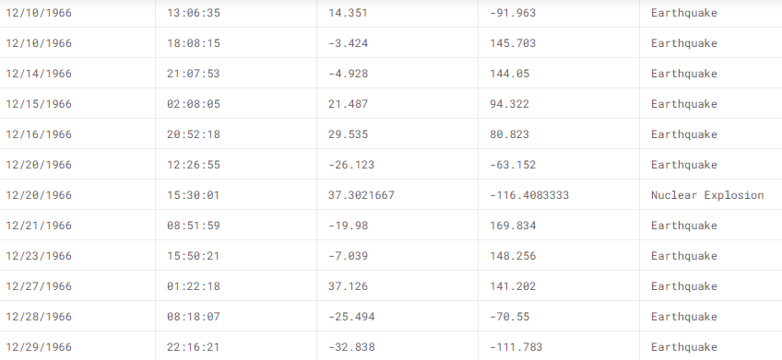

**3 or 4 screenshots of relevant, “inspiring” visualizations that frame your creative fodder:**

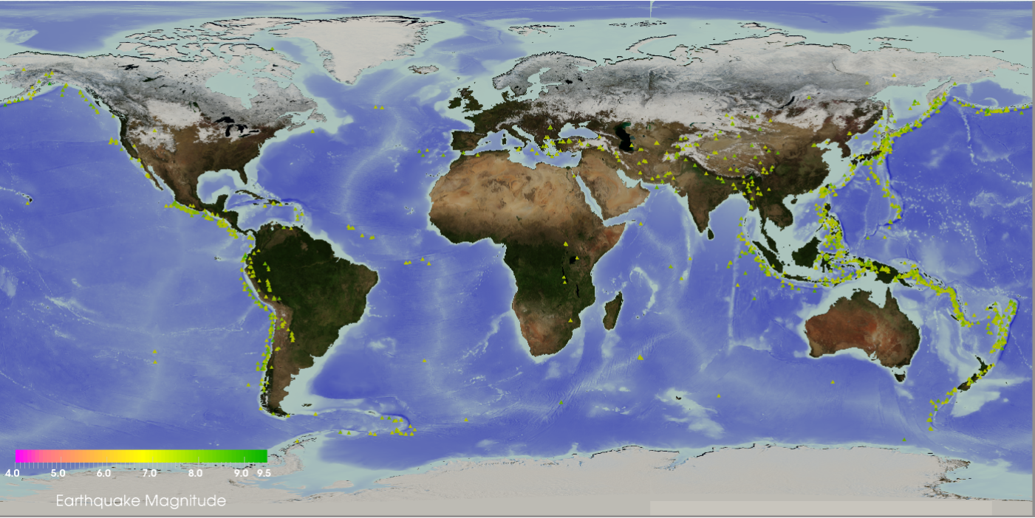 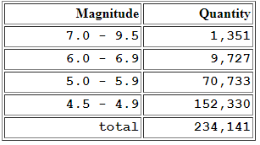

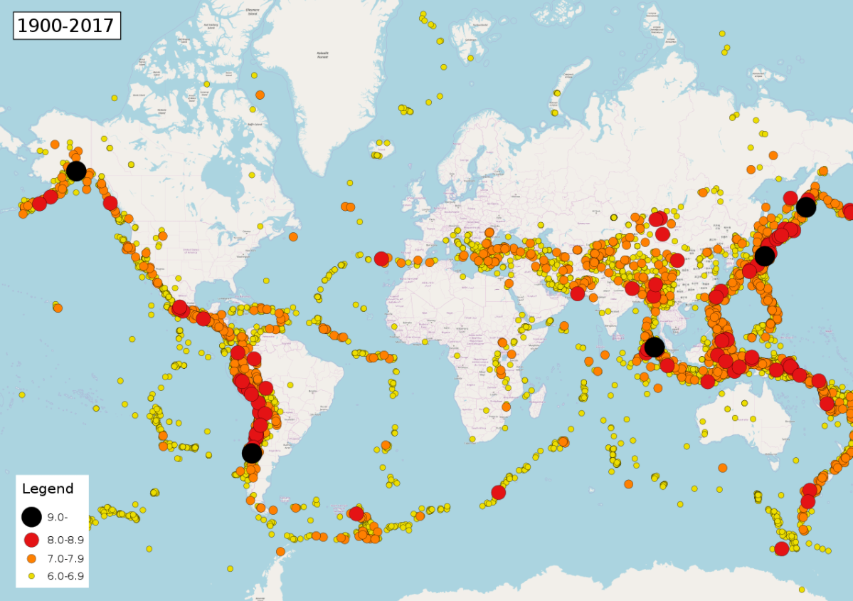

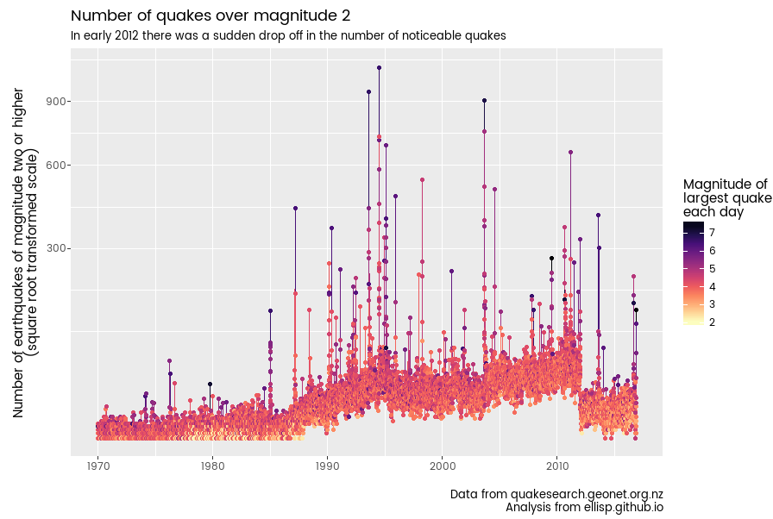

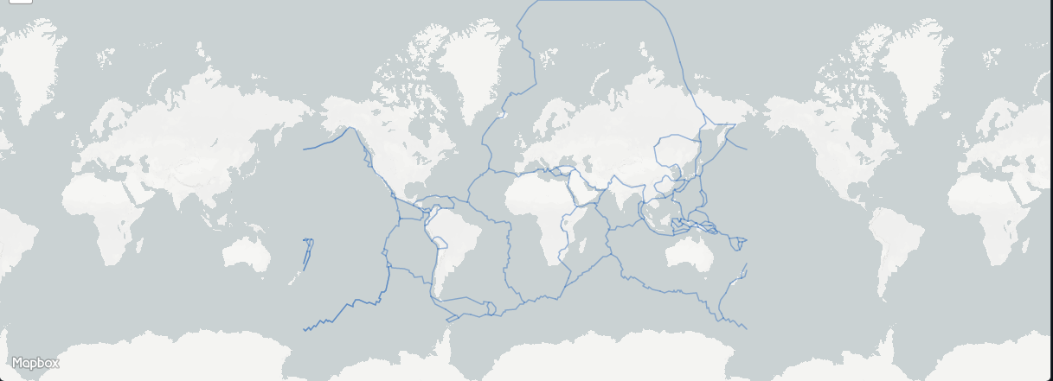

**A sketch* of the final design: *sketch means write out yeah? Yeah okay**

Basic design of project will be a couple pages with different questions to answer on each page. Each page will include graphs and data that answer a specific question. There will be a main page that has a dropdown that will link to these pages. The pages will detail:

1. Whether or not earthquakes are getting worse over time – or higher in magnitude

2. Are earthquakes more prevalent in the northern hemisphere or southern

3. Are there locations where many earthquakes are concurrent with other locations

**A link to the primary GitHub repository you’ll be housing your work in:**

https://github.com/contourdesign/project-2.git